
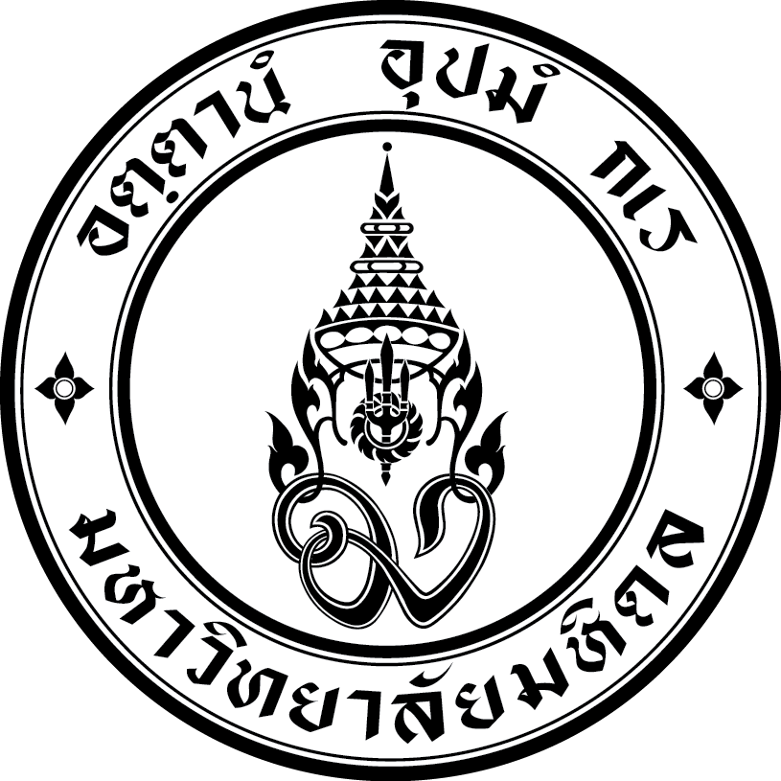

Attach a recent
photograph
here securely
FORM 3

MAHIDOL UNIVERSITY
FACULTY OF DENTISTRY

IDCMR SCHOLARSHIP 2025
Application for Admission
Postgraduate Program (Academic year 2026)

*Complete all sections using BLOCK LETTERS

1. PERSONAL INFORMATION

FirstName MiddleName FamilyName

Title Date of birth Age years
Mr Ms Mrs Day Month Year

Faculty member  Professor

❑ Associate Professor

❑ Assistant Professor

❑ Dr. / Lecturer

Institution: _________________________________________________________

Responsible Teaching Tasks: ___________________________________________

Working Years: __________

2. ADMISSION INFORMATION
FORM 3
Doctorate degree Master’s degree

❑ PhD Program in Dental Biomaterials Science  Master of Science Program in Implant Dentistry
Application’s Name ……………………………..
(*Please see specific conditions of this program in the Postgraduate Program scholarship announcement)

❑ PhD Program in Oral Biology  Master of Science Program in Oral Biology
and Integrative Biomedical Science and Integrative Biomedical Science

Master of Science Program in Dentistry:

❑ Major in Advanced General Dentistry
❑ Major in Community Dentistry
❑ Major in Maxillofacial Prosthetics
❑ Major in Oral and Maxillofacial Surgery
❑ Major in Oral and Maxillofacial Radiology
❑ Major in Pediatric Dentistry

Starting Dates: First Semester: July 2026

3. ADRESS IN HOME COUNTRY (BLOCK LETTERS)

Number and Street

City/Town State Country Postcode

Telephone Fax Fax E-mail

4. CITIZENSHIP (BLOCK LETTERS)

Country of Nationality/ Citizenship

Passport number Expiry date

5. EDUCATION RECORD (BLOCK LETTERS)

Provide details of relevant academic qualifications (undergraduate and postgraduate levels)

Degree | Field | Institution | Country | Year Enrolled  from…to…
 Bachelor

 Postgraduate
(if any)

Application’s Name ……………………………..
FORM 3

6. EMPLOYMENT RECORD (BLOCK LETTERS)

Employer | Period of Employment  from…to… | Position  and Responsibility | Address  (Town, Country)

7. PROFICIENCY IN ENGLISH

Is English your first language? YES NO

Is English the main language spoken in your home country? YES NO

Were your studies at university conducted in English? YES NO

English proficiency test (e.g. IELTS, TOFEL) in the last 2 years

NO YES Name of Test Score

(Original copy of test result: attached)

8. DECLARATION

I declare that to the best of my knowledge, the information I have supplied in this application and the documentation supporting it are correct and complete. I acknowledge that the provision of incorrect information or documentation relating to my application may result in cancellation of any offer of enrollment by the Faculty of Dentistry, Mahidol University.

Applicant’s Signature _________________________________

Name __________________________________

Date __________________________________

Applicant’s approval from the Dean

Dean’s Signature __________________________________

Institution __________________________________

Name __________________________________

Date __________________________________

Checklist of required documents

❑ 1. One completed application Form 3

❑ 2. One recent photograph (attached to application form) 3 cm x 4 cm

❑ 3. One copy of degree certificate

❑ 4. One copy of certified academic transcripts or grade report

❑ 5. One copy of statement with study plan and career goals (300 words)

❑ 6. A brief research proposal

❑ 7. Two letters of recommendation from university

❑ 8. One copy of valid English Proficiency Test score (within 2 years)

❑ 9. Copies of required document specified as stated in www.grad.mahidol.ac.th by each program

Return this form and attachments to:

International Relations Office
Faculty of Dentistry, Mahidol University
6 Yothi Street, Ratchathewi,
Bangkok 10400, Thailand
Tel: 66 (2) 200 - 7600
Fax: 66 (2) 200 - 7609
E-mail: dtinter@mahidol.ac.th

